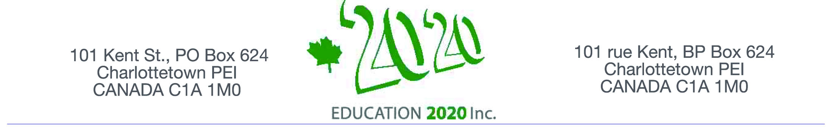

May 11, 2018

Mr. Don Smith
25 Riverside Drive
Charlottetown, PE C1A 9R9

Dear: Mr. Smith

Education 20/20 thanks you for your generous donation. .

Please detach the receipt below and retain for income tax purposes.

Thank You,

Donald E. M. Glendenning
President

l

Tel: 902-892-2060 E-mail: pei@education2020.ca Website: www.edication2020.ca

Receipt No. 2018-5 Re: Assist with Souris project
Date of Donation: May 11, 2018 Date Receipt Issued: May 11, 2018
Received from:

Mr. Don Smith
25 Riverside Drive
Charlottetown, PE C1S 9R9

Authorized representative: _________________________________________

Thank You

Official Receipt for Income Tax Purposes NO. -80082 7081 RR0001
For information on all registered charities in Canada under the Income Tax Act please visit:
Canada Revenue Agency www.cra-arc.gc.ca/charitiesandgiving

Fin/Rec/2018

